Dear Parent’s,
We are excited to announce that we are doing a fabulous fundraising activity with “ToucanDoo” Children’s art on a plate.
This fundraising event is easy as there is no doorknocking or selling involved. All you have to do is allow your children to do a drawing, painting or collage on the supplied template, return your payment envelope and we will do the rest.
We will do this in class time or We will send the templates home for the children to do their masterpieces. (for more successful fundraising results, we suggest you do these in class time and hand out the envelopes) Siblings who don’t attend (name of kindy) are also welcome to design their own plate. If there are any absentee’s in the period of the activity, templates can be sent home so no one has to miss out.
All plates cost $20 each. This is a small investment for something that will give your children many years of enjoyment as you serve their dinner on their very own plate. They also make wonderful unique gifts.
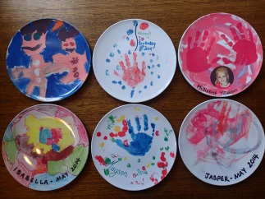 You won’t find a product like this anywhere else

These plates are 20cm in diameter which is the perfect size for a child’s meal.

Plates are BPA free so totally safe to eat off, Unbreakable, Dishwasher safe and the print won’t scratch off as it is made into the plate. They are finished with a beautiful glossy surface. These plates will still be around when your children have their children.

All funds received will go to __________________________________________ which will assist with _________________________________________________________________

Together we can make a difference

This is how easy it is to help raise funds for Place the fundraising cause here
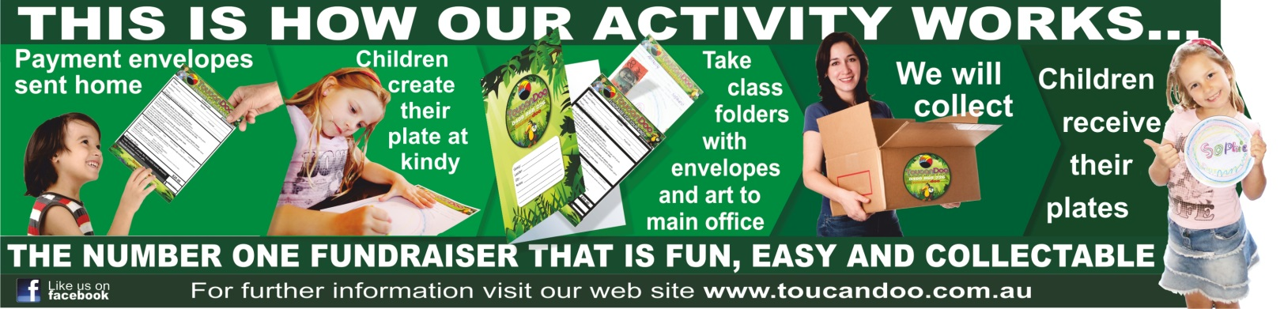
Payment envelopes will be sent home insert dates envelopes sent home. Please fill in all of the required details and use any of our easy payment options on or before insert payment due date here.
The children will complete their creations at insert kindy here.
Children can do paintings, drawings, collages…
The only limitation is their imagination.
So, we encourage you to get involved, help raise funds for insert your cause here and have an awesome keepsake that is practical, beautiful and unbreakable.
These plates also make great unique gifts.
There are different payment options to suit everyone’s needs.
PayPal online, Direct Deposit, Credit Card or Cash.
Please visit our website www.toucandoo.com.au for more information.
Kind regards

ToucanDoo

