Dear Parent’s,
We would like to say a Huge thank you to everyone who has supported our cause. Not only do the funds go towards insert what the funds will assist with, but you also will receive a precious keepsake that will last forever
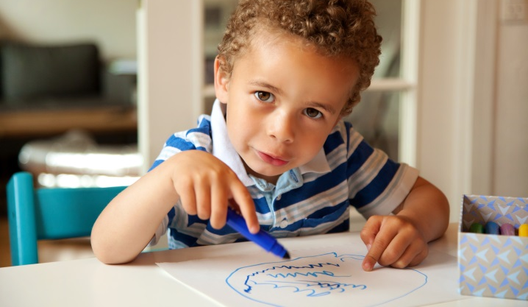
We raised a total amount of $ insert amount here
We will do this as a yearly event so you can have the opportunity to build a collection of your children’s art as they grow.
Your children will be very excited to bring their creation home.
Kind regards
ToucanDoo
www.toucandoo.com.au

